The Tramways of Upper Silesia
A Guidebook

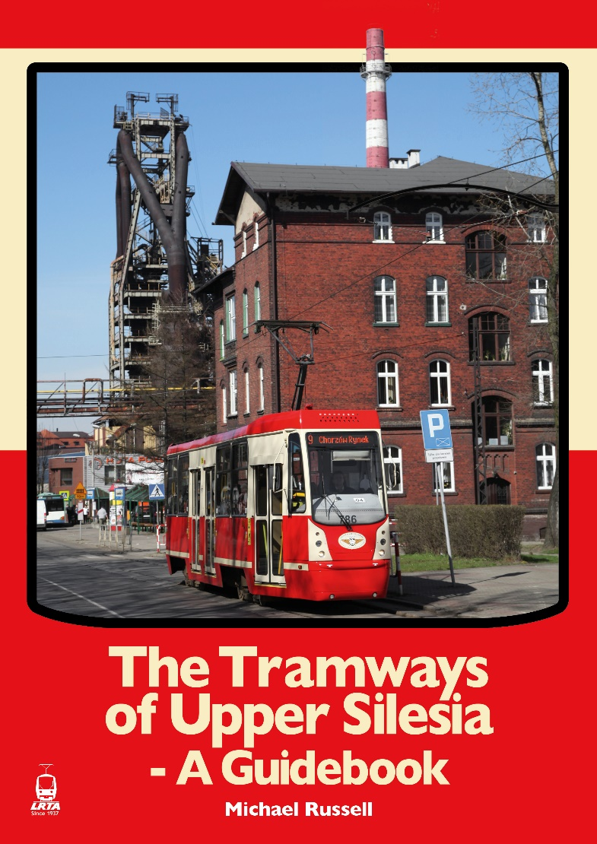

A Guidebook (2022)

Tells the story of a truly remarkable network in a region of Poland rich in mineral resources, which was at serious risk of closure in the post-industrial era but has survived and regenerated itself to become an important player in the regional transport infrastructure.
Local political support and a determined and committed management who, even in the darkest days, never lost faith in the tramway’s future potential, has resulted in the transformation of infrastructure and introduction of modern, low-floor rolling stock to cater for the needs of present-day passengers.
The way in which advantage has been taken of well-maintained second-hand articulated cars from cities such as Frankfurt and Vienna, and the very professional manner in which these have been modernised within the tramway company’s workshops, is testament to a vibrant and forward-looking undertaking.
The people of Upper Silesia are lucky to be served by one of the greatest tramway networks the world has ever known.
The book also acts as a comprehensive guide to the system that operates today.
> A4 softback, 240 pages, 300+ black & white and colour pictures, 16 maps plus large-scale folding track plan.
£38.50 (UK addresses); £45.00 (outside UK); £49.50 (Airmail Zone 1); £55.00 (Airmail Zones 2/3)
LRTA Members: £3.50 discount

Further details and to order click through to :-
www.lrta.org

